Economics - Canadian Edition, 15e (Ragan)
Chapter 5 Price Controls and Market Efficiency

5.1 Government-Controlled Prices

1) At any disequilibrium price, whether government controlled or not, the quantity actually exchanged is determined by
A) the elasticity of supply.
B) the elasticity of demand.
C) government decree.
D) the lesser of quantity demanded and quantity supplied.
E) the greater of quantity demanded and quantity supplied.
Answer: D
Diff: 1
Topic: 5.1a. price controls
Skill: Recall
Learning Obj.: 5-2 Compare the short-run and long-run effects of legislated rent controls.
User2: Qualitative

2) Consider a competitive labour market. The likely consequence of a binding minimum wage in this labour market is
A) a labour shortage.
B) a lower wage for all individuals.
C) a higher wage for all individuals.
D) excess demand for workers.
E) unemployment.
Answer: E
Diff: 1
Topic: 5.1a. price controls
Skill: Applied
Learning Obj.: 5-2 Compare the short-run and long-run effects of legislated rent controls.
User2: Qualitative

3) Government price controls are policies that attempt to maintain the
A) quantity bought at less than the quantity sold.
B) quantity sold at less than the quantity bought.
C) the price at some disequilibrium value.
D) market price at equilibrium.
E) price requested by the seller.
Answer: C
Diff: 1
Topic: 5.1a. price controls
Skill: Recall
Learning Obj.: 5-2 Compare the short-run and long-run effects of legislated rent controls.
User2: Qualitative
4) In a market where we observe a disequilibrium, quantity exchanged is determined
A) by the quantity demanded.
B) by the greater of quantity demanded and quantity supplied.
C) by neither quantity demanded nor quantity supplied.
D) by the lesser of quantity demanded and quantity supplied.
E) by the quantity supplied.
Answer: D
Diff: 1
Topic: 5.1a. price controls
Skill: Recall
Learning Obj.: 5-2 Compare the short-run and long-run effects of legislated rent controls.
User2: Qualitative

5) Which of the following statements about government price controls is most accurate. They
A) act as a guideline to producers as to what is a fair price.
B) inform consumers what is the maximum price they should pay.
C) usually set upper or lower limits on prices.
D) ensure that the actual price is at its free-market equilibrium.
E) ensure that transactions take place at a fair price.
Answer: C
Diff: 1
Topic: 5.1a. price controls
Skill: Recall
Learning Obj.: 5-2 Compare the short-run and long-run effects of legislated rent controls.
User2: Qualitative

6) The price of a good or a service can be determined by free interaction of demand and supply or by a government price regulation. One important difference between these two price-determining methods is
A) there are no shortages or surpluses at the free-market equilibrium price.
B) regulated prices are fairer since more people can then afford the goods or services.
C) that a regulated price above the equilibrium price will always result in shortages.
D) the government is in the best position to know the needs of the people.
E) one is capitalist and the other is communist.
Answer: A
Diff: 1
Topic: 5.1a. price controls
Skill: Applied
Learning Obj.: 5-2 Compare the short-run and long-run effects of legislated rent controls.
User2: Qualitative
7) Consider a market in which there is a government-set price. If there is excess demand at this price,
A) the market is in its free-market equilibrium.
B) the market is in disequilibrium.
C) there are unsuccessful sellers.
D) the product has not reached the point of saturation.
E) none of the product will be exchanged.
Answer: B
Diff: 1
Topic: 5.1a. price controls
Skill: Applied
Learning Obj.: 5-2 Compare the short-run and long-run effects of legislated rent controls.
User2: Qualitative

8) In competitive markets, price floors and price ceilings usually lead to
A) shortages.
B) a reduction in quantities exchanged.
C) surpluses.
D) production control by the government.
E) more equitable distributions of commodities.
Answer: B
Diff: 1
Topic: 5.1a. price controls
Skill: Applied
Learning Obj.: 5-2 Compare the short-run and long-run effects of legislated rent controls.
User2: Qualitative

9) In free and competitive markets, shortages are eliminated by
A) government price controls.
B) rationing.
C) black markets.
D) price increases.
E) price decreases.
Answer: D
Diff: 1
Topic: 5.1a. price controls
Skill: Applied
Learning Obj.: 5-2 Compare the short-run and long-run effects of legislated rent controls.
User2: Qualitative

10) In free and competitive markets, surpluses are eliminated by
A) government price controls.
B) government purchases.
C) black markets.
D) price increases.
E) price decreases.
Answer: E
Diff: 1
Topic: 5.1a. price controls
Skill: Applied
Learning Obj.: 5-2 Compare the short-run and long-run effects of legislated rent controls.
User2: Qualitative
11) Suppose the government sets a particular price in the market for gold, which results in an excess supply. In this situation,
A) the market is in equilibrium.
B) the market is in disequilibrium.
C) there are unsuccessful buyers.
D) the gold market has not reached the point of saturation.
E) no gold will be exchanged.
Answer: B
Diff: 1
Topic: 5.1a. price controls
Skill: Applied
Learning Obj.: 5-2 Compare the short-run and long-run effects of legislated rent controls.
User2: Qualitative

12) A minimum permissible price established by the government is called
A) the equilibrium price.
B) the margin price.
C) a price ceiling.
D) a price floor.
E) the fair price.
Answer: D
Diff: 1
Topic: 5.1b. price floors and ceilings
Skill: Recall
Learning Obj.: 5-2 Compare the short-run and long-run effects of legislated rent controls.
User2: Qualitative

13) If the government fixes the price of good X above its free-market equilibrium level, we should expect
A) a surplus of good X to occur.
B) a shortage of good X to occur.
C) an excess demand for good X.
D) a black market to arise for good X.
E) a new free-market equilibrium price to be established.
Answer: A
Diff: 1
Topic: 5.1b. price floors and ceilings
Skill: Applied
Learning Obj.: 5-2 Compare the short-run and long-run effects of legislated rent controls.
User2: Qualitative

14) A legally imposed upper limit on a price is called
A) a price floor.
B) a price support.
C) an excise price.
D) a price ceiling.
E) a government price.
Answer: D
Diff: 1
Topic: 5.1b. price floors and ceilings
Skill: Recall
Learning Obj.: 5-2 Compare the short-run and long-run effects of legislated rent controls.
User2: Qualitative
15) A binding price floor is a
A) minimum price, below equilibrium, below which price is not allowed to fall.
B) maximum price, above equilibrium, which price is not allowed to exceed.
C) minimum price, above equilibrium, below which price is not allowed to fall.
D) maximum price, below equilibrium, which price is not allowed to exceed.
E) any minimum price below which price is not allowed to fall.
Answer: C
Diff: 2
Topic: 5.1b. price floors and ceilings
Skill: Recall
Learning Obj.: 5-2 Compare the short-run and long-run effects of legislated rent controls.
User2: Qualitative

16) A legal price floor is a
A) price set by the government at which all goods or services must be legally sold.
B) maximum price above which sales cannot legally be made.
C) minimum price below which sales cannot legally be made.
D) price above which there would be no demand.
E) price below which there would be no supply.
Answer: C
Diff: 1
Topic: 5.1b. price floors and ceilings
Skill: Recall
Learning Obj.: 5-2 Compare the short-run and long-run effects of legislated rent controls.
User2: Qualitative

17) In which type of market would a government be most likely to establish a "legal" price floor?
A) housing market
B) labour market
C) diamond market
D) electricity market
E) natural gas market
Answer: B
Diff: 2
Topic: 5.1b. price floors and ceilings
Skill: Applied
Learning Obj.: 5-2 Compare the short-run and long-run effects of legislated rent controls.
User2: Qualitative

18) For a price floor to be binding, it must be set
A) very low.
B) at the free-market equilibrium price.
C) below the free-market equilibrium price.
D) at a level such that there exists some unsatisfied demand.
E) above the free-market equilibrium price.
Answer: E
Diff: 1
Topic: 5.1b. price floors and ceilings
Skill: Recall
Learning Obj.: 5-2 Compare the short-run and long-run effects of legislated rent controls.
User2: Qualitative
19) Consider the market for pulp and paper. Suppose, in an attempt to help this industry, the government sets a price floor above the free-market equilibrium price. The result will be
A) a continuation of the market-determined equilibrium price and quantity.
B) the quantity demanded will exceed quantity supplied and there will be a shortage in the market.
C) the quantity supplied will exceed quantity demanded and there will be a surplus in the market.
D) a new free-market equilibrium at a higher price and lower output level.
E) increased government revenue.
Answer: C
Diff: 2
Topic: 5.1b. price floors and ceilings
Skill: Applied
Learning Obj.: 5-2 Compare the short-run and long-run effects of legislated rent controls.
User2: Qualitative

20) Consider the market for iron ore, an important industrial input. Suppose the government sets a price floor below the free-market equilibrium price. The result will be
A) a continuation of the free-market equilibrium price and quantity.
B) the quantity demanded will exceed quantity supplied and there will be a shortage in the market.
C) the quantity supplied will exceed quantity demanded and there will be a surplus in the market.
D) a new free-market equilibrium at a lower price and higher output level.
E) increased government revenue.
Answer: A
Diff: 2
Topic: 5.1b. price floors and ceilings
Skill: Applied
Learning Obj.: 5-2 Compare the short-run and long-run effects of legislated rent controls.
User2: Qualitative

21) An excess supply of some product is the same thing as
A) a surplus.
B) an excess demand.
C) a shortage.
D) scarcity.
E) price floor.
Answer: A
Diff: 1
Topic: 5.1b. price floors and ceilings
Skill: Recall
Learning Obj.: 5-2 Compare the short-run and long-run effects of legislated rent controls.
User2: Qualitative
22) An excess demand for some product is the same thing as
A) a surplus.
B) an excess supply.
C) a shortage.
D) black market.
E) price ceiling.
Answer: C
Diff: 1
Topic: 5.1b. price floors and ceilings
Skill: Recall
Learning Obj.: 5-2 Compare the short-run and long-run effects of legislated rent controls.
User2: Qualitative

23) Suppose the government establishes a binding price floor for some product. At the price floor,
A) although sellers are selling all of the product that they desire, consumers are not able to buy all that they desire.
B) a new free-market equilibrium price and quantity will be established.
C) both sellers and buyers are satisfied with the quantity that is being exchanged.
D) both sellers and buyers are exchanging the free-market equilibrium quantity.
E) although consumers are purchasing all of the product they desire at this price, the sellers are not selling all they desire.
Answer: E
Diff: 2
Topic: 5.1b. price floors and ceilings
Skill: Recall
Learning Obj.: 5-2 Compare the short-run and long-run effects of legislated rent controls.
User2: Qualitative

24) Suppose the government decides to eliminate a binding price floor that it had previously imposed on a particular good. It can be expected that
A) the price would increase, the quantity demanded would decrease and the quantity supplied would increase.
B) the price would increase, the quantity demanded would increase and the quantity supplied would decrease.
C) the price would decrease, the quantity demanded would decrease and the quantity supplied would increase.
D) the price would decrease, the quantity demanded would increase and the quantity supplied would decrease.
E) no changes would take place.
Answer: D
Diff: 2
Topic: 5.1b. price floors and ceilings
Skill: Applied
Learning Obj.: 5-2 Compare the short-run and long-run effects of legislated rent controls.
User2: Qualitative
25) Suppose the government decides to eliminate a binding price ceiling that it had previously imposed on a particular good. It can be expected that
A) the price would increase, quantity demanded would decrease, and quantity supplied would decrease.
B) the price would increase, quantity demanded would decrease, and quantity supplied would increase.
C) the price would decrease, quantity demanded would decrease, and quantity supplied would increase.
D) the price would decrease, quantity demanded would increase, and quantity supplied would decrease.
E) no change would take place
Answer: B
Diff: 2
Topic: 5.1b. price floors and ceilings
Skill: Applied
User2: Qualitative

26) A binding minimum wage established by the government
A) is essentially a price ceiling that creates a shortage of workers.
B) will be effective only if the minimum wage is set below the free-market equilibrium wage.
C) will have no effect on the quantity of labour employed.
D) will affect adversely only those workers whose value of productivity is greater than this minimum wage.
E) is a price floor that will create a surplus of workers if the labour market is competitive.
Answer: E
Diff: 2
Topic: 5.1b. price floors and ceilings
Skill: Applied
Learning Obj.: 5-2 Compare the short-run and long-run effects of legislated rent controls.
User2: Qualitative

27) If the equilibrium wage in a competitive labour market is $9 per hour, and the government raises the minimum wage from $7 to $8 per hour, what will be the effect in this market?
A) the level of employment will decrease
B) unemployment will increase
C) unemployment will decrease
D) there will be no effect on employment
E) the average wage paid to workers will increase
Answer: D
Diff: 2
Topic: 5.1b. price floors and ceilings
Skill: Applied
Learning Obj.: 5-2 Compare the short-run and long-run effects of legislated rent controls.
User2: Qualitative
28) For a legislated minimum wage to be binding in a competitive labour market, it must be set
A) below the free-market wage.
B) equal to the free-market wage.
C) above the free-market wage.
D) at or below the free-market wage.
E) such that no worker can earn more than the established minimum wage.
Answer: C
Diff: 1
Topic: 5.1b. price floors and ceilings
Skill: Recall
Learning Obj.: 5-2 Compare the short-run and long-run effects of legislated rent controls.
User2: Qualitative

29) A legal price ceiling, if it is binding, is a
A) minimum price, below equilibrium, which price is not allowed to fall below.
B) maximum price, above equilibrium, which price is not allowed to exceed.
C) minimum price, above equilibrium, which price is not allowed to fall below.
D) maximum price, below equilibrium, which a price is not allowed to exceed.
E) any maximum price which price is not allowed to exceed.
Answer: D
Diff: 1
Topic: 5.1b. price floors and ceilings
Skill: Recall
Learning Obj.: 5-2 Compare the short-run and long-run effects of legislated rent controls.
User2: Qualitative

30) A price ceiling set below the free-market equilibrium price will result in
A) a clearing of the market.
B) greater quantity exchanged.
C) surpluses.
D) excess demand.
E) excess supply.
Answer: D
Diff: 1
Topic: 5.1b. price floors and ceilings
Skill: Recall
Learning Obj.: 5-2 Compare the short-run and long-run effects of legislated rent controls.
User2: Qualitative

31) Suppose the free-market equilibrium price for ice time at privately operated hockey arenas is $250 per hour. If the municipal government imposes a price ceiling of $130 per hour, we can expect to see
A) an adjustment of the free-market equilibrium price to $100.
B) an excess supply of ice time.
C) a black market price below the free-market equilibrium price.
D) that neither excess supply nor excess demand is created.
E) an excess demand for ice time.
Answer: E
Diff: 2
Topic: 5.1b. price floors and ceilings
Skill: Applied
Learning Obj.: 5-2 Compare the short-run and long-run effects of legislated rent controls.
User2: Qualitative
32) In a competitive market, a legal price ceiling set above the free-market equilibrium price will result in
A) a continuation of the free-market equilibrium price and quantity.
B) the quantity demanded exceeding quantity supplied and thus a shortage in the market.
C) the quantity supplied exceeding quantity demanded and thus a surplus in the market.
D) a new free-market equilibrium at a higher price and lower output level.
E) increased profits to the firms in the industry.
Answer: A
Diff: 2
Topic: 5.1b. price floors and ceilings
Skill: Recall
Learning Obj.: 5-2 Compare the short-run and long-run effects of legislated rent controls.
User2: Qualitative

33) In a competitive market, a price ceiling set below the free-market equilibrium price will result in
A) a continuation of the free-market equilibrium price and quantity.
B) the quantity demanded exceeding quantity supplied and thus a shortage in the market.
C) the quantity supplied exceeding quantity demanded and thus a surplus in the market.
D) a new free-market equilibrium at a lower price and higher output level.
E) excess supply.
Answer: B
Diff: 2
Topic: 5.1b. price floors and ceilings
Skill: Recall
Learning Obj.: 5-2 Compare the short-run and long-run effects of legislated rent controls.
User2: Qualitative

34) Which of the following statements best differentiates price ceilings and price floors?
A) Price ceilings represent minimum prices, while price floors represent maximum prices.
B) Binding price ceilings are always set below the equilibrium price, whereas binding price floors are always set above the equilibrium price.
C) Price ceilings are always effective, whereas price floors are rarely effective.
D) Price floors cause shortages to appear, whereas price ceilings have the opposite effect.
E) Price ceilings and price floors have the same effects.
Answer: B
Diff: 2
Topic: 5.1b. price floors and ceilings
Skill: Recall
Learning Obj.: 5-2 Compare the short-run and long-run effects of legislated rent controls.
User2: Qualitative
35) Suppose that the free-market equilibrium price of natural gas would be $2.00 per unit, but in an effort to protect consumers the government has fixed the price at $1.50. At this ceiling price the quantity ________ will be greater than the quantity ________, resulting in a ________ of natural gas.
A) demanded; supplied; surplus
B) supplied; demanded; surplus
C) demanded; supplied; shortage
D) supplied; demanded; shortage
E) demanded; supplied; reduction in equilibrium price
Answer: C
Diff: 2
Topic: 5.1b. price floors and ceilings
Skill: Applied
Learning Obj.: 5-2 Compare the short-run and long-run effects of legislated rent controls.
User2: Qualitative

36) Suppose that the free-market equilibrium price of downtown-to-airport taxi service would be $45 per trip, but in an effort to protect taxi owners the government has fixed the price at $60 per trip. At this legislated price the quantity ________ will be greater than the quantity ________, resulting in a ________ of downtown-to-airport taxi services.
A) demanded; supplied; surplus
B) supplied; demanded; surplus
C) demanded; supplied; shortage
D) supplied; demanded; shortage
E) demanded; supplied; reduction in equilibrium price
Answer: B
Diff: 2
Topic: 5.1b. price floors and ceilings
Skill: Applied
User2: Qualitative

37) If the free-market equilibrium price for some product is $25, then a legal price ceiling set at $15 will bring about
A) the same general effects as a price ceiling of $25.
B) the same general effects as an equilibrium price of $15.
C) no change in the market outcomes.
D) a surplus of the good.
E) a shortage of the good.
Answer: E
Diff: 1
Topic: 5.1b. price floors and ceilings
Skill: Applied
Learning Obj.: 5-2 Compare the short-run and long-run effects of legislated rent controls.
User2: Qualitative
38) Which of the following is true of price ceilings?
A) Firms must charge the price established as a price ceiling.
B) If the ceiling price is set above the free-market equilibrium price it will have no effect on the market.
C) A ceiling price below the free-market equilibrium price is not binding.
D) With a non-binding ceiling price an excess demand for the product will develop.
E) With a binding ceiling price a surplus of the commodity will develop.
Answer: B
Diff: 2
Topic: 5.1b. price floors and ceilings
Skill: Applied
Learning Obj.: 5-2 Compare the short-run and long-run effects of legislated rent controls.
User2: Qualitative

39) With respect to some commodity, X, if government objectives are to (1) restrict production and (2) keep prices down to protect consumers, then legislated price ceilings will
A) be a dismal failure as neither goal can ever be achieved with price ceilings.
B) satisfy both goals but only if a black market develops.
C) satisfy only the second goal if a black market develops.
D) only have an effect on commodities at the international level.
E) satisfy both goals as long as a black market does not develop.
Answer: E
Diff: 3
Topic: 5.1b. price floors and ceilings
Skill: Applied
Learning Obj.: 5-2 Compare the short-run and long-run effects of legislated rent controls.
User2: Qualitative

40) Which of the following is an example of a black-market transaction?
A) A person buys a hotdog on a street corner.
B) A person buys a product at a price greater than the government-imposed ceiling price.
C) A person buys a product at a price below the government-imposed ceiling price.
D) A person places a bet at a racetrack.
E) A person buys a product at a price greater than the government-imposed price floor.
Answer: B
Diff: 1
Topic: 5.1b. price floors and ceilings
Skill: Applied
Learning Obj.: 5-2 Compare the short-run and long-run effects of legislated rent controls.
User2: Qualitative
41) If the government imposes a price ceiling for some product, and a black market subsequently develops that gains control of all of the reduced output of the product, then
A) the black market price will be lower than the ceiling price.
B) excess profits will flow back to consumers.
C) the quantity demanded will exceed quantity supplied at the black market price.
D) the black market price will be higher than the free-market equilibrium price.
E) consumers will be better off than they would be in the absence of the black market.
Answer: D
Diff: 2
Topic: 5.1b. price floors and ceilings
Skill: Applied
Learning Obj.: 5-2 Compare the short-run and long-run effects of legislated rent controls.
User2: Qualitative

42) If a binding price floor is in place and if the demand curve for the product shifts rightward, one consequence would be
A) an increase in the amount of excess demand.
B) a decrease in the amount of excess demand.
C) an increase in the amount of excess supply.
D) a decrease in the amount of excess supply.
E) a decrease in the quantity exchanged.
Answer: D
Diff: 2
Topic: 5.1b. price floors and ceilings
Skill: Applied
Learning Obj.: 5-2 Compare the short-run and long-run effects of legislated rent controls.
User2: Qualitative

43) If a binding price ceiling is in place and if the demand curve for the product shifts rightward, one consequence would be
A) the quantity exchanged would increase.
B) the quantity exchanged would remain constant.
C) the quantity exchanged would decrease.
D) an increase in the amount of excess supply.
E) a decrease in the amount of excess demand.
Answer: B
Diff: 2
Topic: 5.1b. price floors and ceilings
Skill: Applied
Learning Obj.: 5-2 Compare the short-run and long-run effects of legislated rent controls.
User2: Qualitative
44) The surpluses associated with a binding price floor will be the smallest when
A) both supply and demand are highly elastic.
B) both supply and demand are highly inelastic.
C) supply is highly elastic and demand is highly inelastic.
D) supply is highly inelastic and demand is highly elastic.
E) both supply and demand are unit elastic.
Answer: B
Diff: 2
Topic: 5.1b. price floors and ceilings
Skill: Applied
Learning Obj.: 5-2 Compare the short-run and long-run effects of legislated rent controls.
User2: Qualitative

45) The shortages associated with a binding price ceiling will be the smallest when
A) both supply and demand are highly elastic.
B) both supply and demand are highly inelastic.
C) supply is highly elastic and demand is highly inelastic.
D) supply is highly inelastic and demand is highly elastic.
E) none of the above—the size of the shortage has nothing to do with demand and supply elasticities.
Answer: B
Diff: 3
Topic: 5.1b. price floors and ceilings
Skill: Applied
Learning Obj.: 5-2 Compare the short-run and long-run effects of legislated rent controls.
User2: Qualitative

46) A predictable result of the imposition of binding price floors or price ceilings is
A) shortages.
B) a reduction in quantities exchanged.
C) surpluses.
D) production control by the government.
E) a more equitable distribution of commodities.
Answer: B
Diff: 1
Topic: 5.1b. price floors and ceilings
Skill: Recall
Learning Obj.: 5-2 Compare the short-run and long-run effects of legislated rent controls.
User2: Qualitative

47) If the equilibrium price for some product is $1000, a price ceiling of $1200 will result in
A) the same general effects as a price floor of $1200.
B) the same general effects as an administered price of $1200.
C) the same general effects as a price ceiling of $600.
D) massive surpluses of the good.
E) no effects because the price ceiling is not binding at that price.
Answer: E
Diff: 2
Topic: 5.1b. price floors and ceilings
Skill: Applied
Learning Obj.: 5-2 Compare the short-run and long-run effects of legislated rent controls.
User2: Qualitative
48) If the equilibrium price for some product is $1000, a price ceiling of $800 will result in
A) the same general effects as a price ceiling of $1200.
B) the same general effects as a price floor of $1200.
C) the same general effects as a price ceiling of $600.
D) massive surpluses of the good.
E) no effects because the price ceiling is not binding at that price.
Answer: C
Diff: 2
Topic: 5.1b. price floors and ceilings
Skill: Applied
Learning Obj.: 5-2 Compare the short-run and long-run effects of legislated rent controls.
User2: Qualitative

49) If a binding price ceiling is in effect and if the demand for the product increases, one consequence would be
A) a decrease in the amount of excess supply.
B) a decrease in the amount of excess demand.
C) an increase in the amount of excess supply.
D) an increase in the amount of excess demand.
E) no change in the excess supply or demand for the product.
Answer: D
Diff: 2
Topic: 5.1b. price floors and ceilings
Skill: Applied
Learning Obj.: 5-2 Compare the short-run and long-run effects of legislated rent controls.
User2: Qualitative

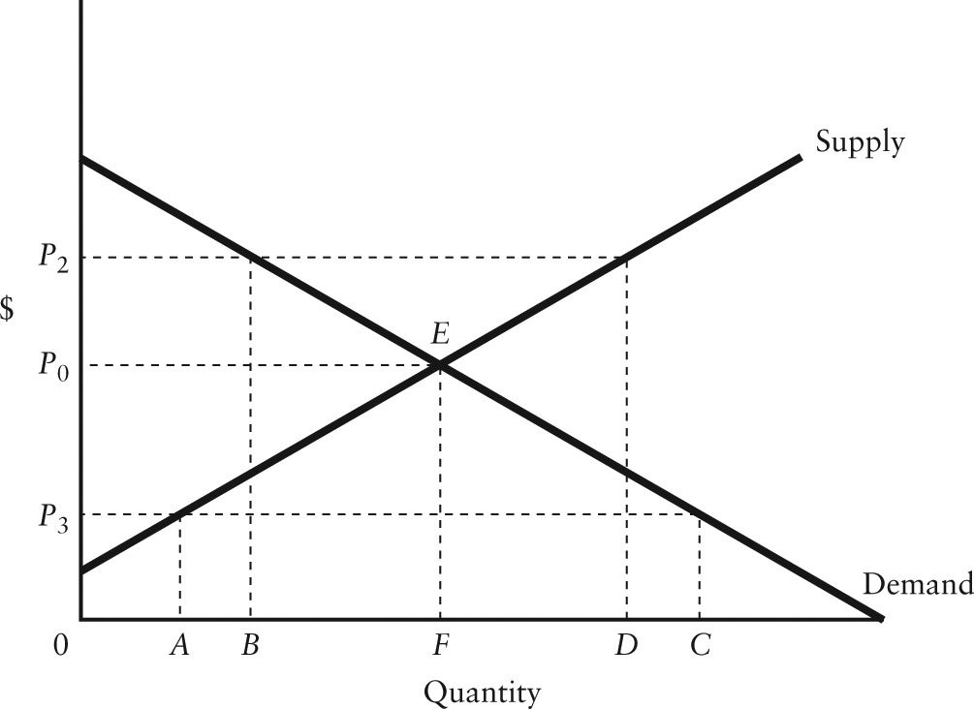

FIGURE 5-1

50) Refer to Figure 5-1. In this market, suppose the government announces that the price must be P2 or higher. This price (P2) is referred to as
A) a price ceiling.
B) a price floor.
C) a non-binding price floor.
D) a binding price ceiling.
E) an equilibrium price.
Answer: B
Diff: 1
Topic: 5.1b. price floors and ceilings
Skill: Applied
Learning Obj.: 5-2 Compare the short-run and long-run effects of legislated rent controls.
User1: Graph
User2: Qualitative

51) Refer to Figure 5-1. In this market, suppose the government announces that the price must be P3 or lower. This price (P3) is referred to as
A) a non-binding price ceiling.
B) a binding price floor.
C) an equilibrium price.
D) a price ceiling.
E) a price floor.
Answer: D
Diff: 1
Topic: 5.1b. price floors and ceilings
Skill: Applied
Learning Obj.: 5-2 Compare the short-run and long-run effects of legislated rent controls.
User1: Graph
User2: Qualitative

52) Refer to Figure 5-1. If the government imposes an administered price at P2, the result will be a
A) surplus of BD.
B) shortage of AC.
C) shortage of FD.
D) surplus of AF.
E) surplus of 0D.
Answer: A
Diff: 2
Topic: 5.1b. price floors and ceilings
Skill: Applied
Learning Obj.: 5-2 Compare the short-run and long-run effects of legislated rent controls.
User1: Graph
User2: Qualitative
53) Refer to Figure 5-1. If the diagram applies to the labour market, and P3 represents a legislated minimum wage,
A) there will be excess demand of AC in the labour market.
B) there will be unemployment of AC in the labour market.
C) the free-market equilibrium wage is P0 and the labour market is unaffected by the minimum wage.
D) the labour market is in disequilibrium.
E) the amount of labour employed will rise from quantity F to quantity C.
Answer: C
Diff: 2
Topic: 5.1b. price floors and ceilings
Skill: Applied
Learning Obj.: 5-2 Compare the short-run and long-run effects of legislated rent controls.
User1: Graph
User2: Qualitative

54) Refer to Figure 5-1. To be binding, a legal price ceiling must lie
A) above P0 but below P2.
B) anywhere above P0.
C) below P0 but above P3.
D) anywhere below P0.
E) anywhere above 0.
Answer: D
Diff: 1
Topic: 5.1b. price floors and ceilings
Skill: Applied
Learning Obj.: 5-2 Compare the short-run and long-run effects of legislated rent controls.
User1: Graph
User2: Qualitative

55) Refer to Figure 5-1. With a price ceiling of P3, how large will the resulting shortage be?
A) FD
B) AF
C) AC
D) BC
E) FC
Answer: C
Diff: 2
Topic: 5.1b. price floors and ceilings
Skill: Applied
Learning Obj.: 5-2 Compare the short-run and long-run effects of legislated rent controls.
User1: Graph
User2: Qualitative
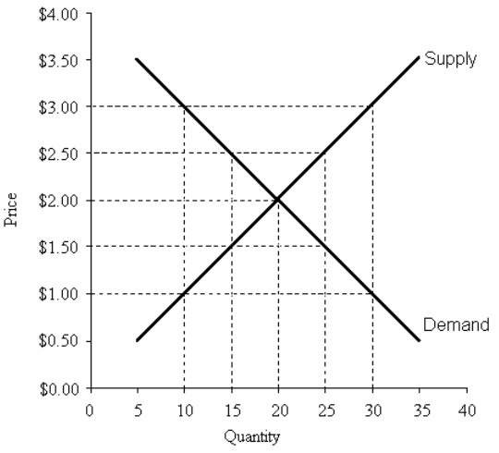

FIGURE 5-2

56) Refer to Figure 5-2. A price floor set at $2.50 will result in
A) a shortage of 5 units.
B) a shortage of 10 units.
C) a surplus of 10 units.
D) a surplus of 5 units.
E) no change to the market outcomes.
Answer: C
Diff: 2
Topic: 5.1b. price floors and ceilings
Skill: Applied
Learning Obj.: 5-2 Compare the short-run and long-run effects of legislated rent controls.
User1: Graph
User2: Quantitative

57) Refer to Figure 5-2. A price floor set at a price of $1.00 will result in
A) a shortage of 10 units.
B) a shortage of 20 units.
C) a surplus of 10 units.
D) a surplus of 20 units.
E) no change in the market outcomes.
Answer: E
Diff: 2
Topic: 5.1b. price floors and ceilings
Skill: Applied
Learning Obj.: 5-2 Compare the short-run and long-run effects of legislated rent controls.
User1: Graph
User2: Quantitative
58) Refer to Figure 5-2. A price ceiling set at a price of $1.00 per unit will result in
A) a shortage of 10 units.
B) a shortage of 20 units.
C) a surplus of 10 units.
D) a surplus of 20 units.
E) no change to the market outcomes.
Answer: B
Diff: 2
Topic: 5.1b. price floors and ceilings
Skill: Applied
Learning Obj.: 5-2 Compare the short-run and long-run effects of legislated rent controls.
User1: Graph
User2: Quantitative

59) Refer to Figure 5-2. A price ceiling set at a price of $2.50 per unit will result in
A) a shortage of 5 units.
B) a shortage of 10 units.
C) a surplus of 5 units.
D) a surplus of 10 units.
E) no change in the market outcomes.
Answer: E
Diff: 2
Topic: 5.1b. price floors and ceilings
Skill: Applied
Learning Obj.: 5-2 Compare the short-run and long-run effects of legislated rent controls.
User1: Graph
User2: Quantitative
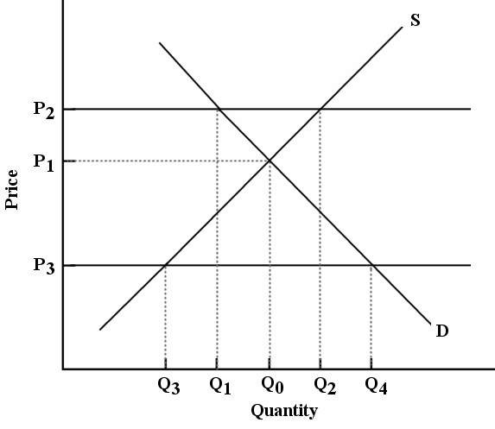

FIGURE 5-3

60) Refer to Figure 5-3. P2 represents a price imposed by the government. What is the quantity of this good that would be exchanged in the market?
A) Q0
B) Q1
C) Q2
D) Q3
E) Q4
Answer: B
Diff: 2
Topic: 5.1b. price floors and ceilings
Skill: Applied
Learning Obj.: 5-2 Compare the short-run and long-run effects of legislated rent controls.
User1: Graph
User2: Qualitative

61) Refer to Figure 5-3. To be effective, a price floor must lie
A) above P1 but below P2.
B) anywhere above P1.
C) below P1 but above P3.
D) anywhere below P1.
E) within the boundaries of P2 and P3.
Answer: B
Diff: 2
Topic: 5.1b. price floors and ceilings
Skill: Applied
Learning Obj.: 5-2 Compare the short-run and long-run effects of legislated rent controls.
User1: Graph
User2: Qualitative
62) Refer to Figure 5-3. Suppose P3 represents a price imposed by the government. The result would be
A) excess supply of Q3Q4.
B) excess supply of Q3Q0.
C) excess demand of Q0Q2.
D) excess demand of Q1Q2.
E) excess demand of Q3Q4.
Answer: E
Diff: 2
Topic: 5.1b. price floors and ceilings
Skill: Applied
Learning Obj.: 5-2 Compare the short-run and long-run effects of legislated rent controls.
User1: Graph
User2: Qualitative

63) Refer to Figure 5-3. If the government imposes a price floor at P3, the result would be a price and quantity combination of
A) P3 and Q3.
B) P3 and Q4.
C) P2 and Q1.
D) P1 and Q0.
E) P3 and Q0.
Answer: D
Diff: 2
Topic: 5.1b. price floors and ceilings
Skill: Applied
Learning Obj.: 5-2 Compare the short-run and long-run effects of legislated rent controls.
User1: Graph
User2: Qualitative

64) Suppose the demand for eggs is inelastic and that the market-clearing price is $1.50 per dozen. Now suppose the government imposes a minimum price of $2.00 per dozen. Why might the government implement such a policy?
A) to make consumers better off
B) to increase the incomes of egg farmers
C) to increase excess demand in the egg market
D) to reduce excess supply in the egg market
E) to decrease tax revenues from egg farmers
Answer: B
Diff: 3
Topic: 5.1b. price floors and ceilings
Skill: Applied
Learning Obj.: 5-2 Compare the short-run and long-run effects of legislated rent controls.
User2: Qualitative
65) Concert promoters often set ticket prices below what they expect the market-clearing price to be. They are effectively imposing a ________ and the result is often ________ at a considerably higher price.
A) price ceiling; ticket scalping
B) price floor; ticket scalping
C) price ceiling; a surplus
D) price floor; a shortage
E) fair price; excess tickets
Answer: A
Diff: 2
Topic: 5.1b. price floors and ceilings
Skill: Applied
Learning Obj.: 5-2 Compare the short-run and long-run effects of legislated rent controls.
User2: Qualitative

Demand and Supply Schedules for Chocolate Bars

Price  ($) | Quantity Demanded  (thousands per week) | Quantity Supplied  (thousands per week)
2.00 | 1500 | 2100
1.80 | 1600 | 2050
1.60 | 1700 | 2000
1.40 | 1800 | 1950
1.20 | 1900 | 1900
1.00 | 2000 | 1850
0.80 | 2100 | 1800
0.60 | 2200 | 1750
0.40 | 2300 | 1700

TABLE 5-1

66) Refer to Table 5-1. Suppose that as a public-health measure the government wants to reduce the number of chocolate bars that children consume. To achieve this outcome the government could implement which of the following policies?
A) Impose an equilibrium price of $1.80.
B) Impose a price floor of $1.80.
C) Impose a price ceiling of $1.80.
D) Impose an equilibrium price of $1.20.
E) Impose a price ceiling of $2.00.
Answer: B
Diff: 2
Topic: 5.1b. price floors and ceilings
Skill: Applied
Learning Obj.: 5-2 Compare the short-run and long-run effects of legislated rent controls.
User1: Table
User2: Qualitative
67) Refer to Table 5-1. Suppose the government imposed a price of $0.60 per chocolate bar. The result would be
A) excess demand of 450 chocolate bars per week.
B) excess supply of 450 chocolate bars per week.
C) excess supply of 1750 chocolate bars per week.
D) excess demand of 2200 chocolate bars per week.
E) stockpiling of unsold chocolate bars.
Answer: A
Diff: 3
Topic: 5.1b. price floors and ceilings
Skill: Applied
Learning Obj.: 5-2 Compare the short-run and long-run effects of legislated rent controls.
User1: Table
User2: Quantitative

68) Refer to Table 5-1. Suppose the government imposed a price of $1.80 per chocolate bar. A likely result from this policy is
A) the development of a black market in chocolate bars.
B) the allocation of chocolate bars by sellers preference.
C) the allocation of chocolate bars on a first-come, first-serve basis.
D) the stockpiling of unsold inventories of chocolate bars.
E) the rationing of chocolate bars.
Answer: D
Diff: 3
Topic: 5.1b. price floors and ceilings
Skill: Applied
Learning Obj.: 5-2 Compare the short-run and long-run effects of legislated rent controls.
User1: Table
User2: Qualitative

69) Refer to Table 5-1. Suppose the government established a price floor of $1.00 per chocolate bar. How many thousands of chocolate bars would be exchanged per week?
A) 2000
B) 1850
C) 1900
D) 1800
E) 2100
Answer: C
Diff: 2
Topic: 5.1b. price floors and ceilings
Skill: Applied
Learning Obj.: 5-2 Compare the short-run and long-run effects of legislated rent controls.
User1: Table
User2: Quantitative
70) Refer to Table 5-1. Suppose the government established a price ceiling of $1.00 per chocolate bar. How many thousands of chocolate bars would be exchanged per week?
A) 1800
B) 1850
C) 1900
D) 2000
E) 2100
Answer: B
Diff: 2
Topic: 5.1b. price floors and ceilings
Skill: Applied
User1: Table
User2: Quantitative

71) Refer to Table 5-1. Suppose that as a public health measure the government wants to reduce the number of chocolate bars consumed by children. If the government imposes a price of $1.60 per chocolate bar, how many fewer chocolate bars will be consumed each week, relative to the competitive equilibrium?
A) 200
B) 300
C) 1700
D) 2000
E) 1800
Answer: A
Diff: 2
Topic: 5.1b. price floors and ceilings
Skill: Applied
Learning Obj.: 5-4 Explain why government interventions that cause prices to deviate from their market‐clearing levels tend to be inefficient for society as a whole.
User1: Table
User2: Quantitative
5.2 Rent Controls: A Case Study of Price Ceilings

FIGURE 5-1

1) Refer to Figure 5-1. If the diagram applies to the market for rental housing and P3 represents the maximum rent that can be charged, then
A) there will be an excess supply of rental units equal to BD.
B) units supplied will be reduced relative to the competitive equilibrium by AF rental units.
C) windfall profits will be earned by landlords.
D) there will be excess demand for rental units equal to FC.
E) there will be excess demand for rental units equal to AF.
Answer: B
Diff: 2
Topic: 5.2. rent controls
Skill: Applied
Learning Obj.: 5-3 Describe the relationship between economic surplus and the efficiency of a market.
User1: Graph
User2: Qualitative
2) In the presence of binding rent controls, the shortage of housing is smaller
A) the higher is the elasticity of demand for housing.
B) the lower is the elasticity of supply of housing.
C) the longer is the length of time the rent controls are in place.
D) the greater is the difference between the equilibrium price and the rent-controlled price.
E) the more elastic is the long-run supply of housing.
Answer: B
Diff: 2
Topic: 5.2. rent controls
Skill: Applied
Learning Obj.: 5-3 Describe the relationship between economic surplus and the efficiency of a market.
User2: Qualitative

3) Consider the market for rental accommodation. In the short run, the supply of this product tends to be
A) infinitely price elastic.
B) very price elastic.
C) unit price elastic.
D) very or completely price inelastic.
E) irrelevant to the housing market price.
Answer: D
Diff: 2
Topic: 5.2. rent controls
Skill: Applied
Learning Obj.: 5-3 Describe the relationship between economic surplus and the efficiency of a market.
User2: Qualitative

4) Which of the explanations below best describes why a government might choose to impose binding rent controls?
A) To prevent landlords from making excess profits and to protect low-income tenants from increases in the cost of housing.
B) To prevent landlords from making excess profits and to reduce the long-term quantity of rental housing.
C) To increase the demand for rental housing and to discourage private ownership of low-cost rental housing developments.
D) To stabilize volatile rents, and thus to make the investment climate less uncertain for prospective investors in this sector.
E) To stimulate employment in the construction industry through the increased demand for new houses.
Answer: A
Diff: 1
Topic: 5.2. rent controls
Skill: Recall
Learning Obj.: 5-3 Describe the relationship between economic surplus and the efficiency of a market.
User2: Qualitative
5) Suppose the government establishes a ceiling on the price of rental accommodation that is lower than the free-market equilibrium price. In this case,
A) construction of new rental units will be encouraged.
B) the rental housing market will be unaffected.
C) those people who obtain rental units at the ceiling price will benefit.
D) a surplus of current rental units will develop.
E) the current stock of rental housing will be better maintained as there is a shortage of housing.
Answer: C
Diff: 2
Topic: 5.2. rent controls
Skill: Applied
Learning Obj.: 5-3 Describe the relationship between economic surplus and the efficiency of a market.
User2: Qualitative

6) Assume that the long-run supply of housing is highly elastic. The imposition of binding rent controls will lead to
A) a reduction in the housing shortage over time.
B) a worsening of the housing shortage over time.
C) no significant change in the housing shortage over time.
D) only a temporary housing shortage.
E) the price of rental housing to revert back to its free-market equilibrium level.
Answer: B
Diff: 2
Topic: 5.2. rent controls
Skill: Applied
Learning Obj.: 5-3 Describe the relationship between economic surplus and the efficiency of a market.
User2: Qualitative

7) The use of legislated rent controls typically
A) has no effect on the distribution of income between tenants and landlords or on the availability of rental accommodations.
B) affects the distribution of income between tenants and landlords but does not affect the supply of rental accommodations.
C) has no effect on the distribution of income between tenants and landlords but does affect the supply of rental accommodations.
D) affects the distribution of income between tenants and landlords and also affects the availability of rental accommodations.
E) has much worse effects in the short run than in the long run.
Answer: D
Diff: 2
Topic: 5.2. rent controls
Skill: Recall
Learning Obj.: 5-3 Describe the relationship between economic surplus and the efficiency of a market.
User2: Qualitative
8) Suppose the government imposes a price ceiling on rental housing that is below the market-clearing price. The resulting shortage will be
A) greater the more recently the controlled price went into effect.
B) smaller the longer the controlled price has been in effect.
C) greater the more elastic the demand for rental housing.
D) smaller the more elastic the demand for rental housing.
E) diminished over time.
Answer: C
Diff: 2
Topic: 5.2. rent controls
Skill: Applied
Learning Obj.: 5-3 Describe the relationship between economic surplus and the efficiency of a market.
User2: Qualitative

9) Assuming that the long-run supply of housing is more ________ than the short-run supply, the imposition of binding rent controls will generally ________.
A) inelastic; lead to a reduction in the housing shortage over time
B) elastic; lead to a worsening of the housing shortage over time
C) inelastic; lead to no significant change in the housing shortage
D) elastic; lead to only a temporary housing shortage
E) elastic; lead the price of rental housing to revert back to its equilibrium level
Answer: B
Diff: 2
Topic: 5.2. rent controls
Skill: Applied
Learning Obj.: 5-3 Describe the relationship between economic surplus and the efficiency of a market.
User2: Qualitative

10) Who are likely to be the biggest beneficiaries of rent controls?
A) landlords
B) prospective tenants
C) current tenants
D) construction companies
E) no group will benefit from the controls
Answer: C
Diff: 2
Topic: 5.2. rent controls
Skill: Recall
Learning Obj.: 5-3 Describe the relationship between economic surplus and the efficiency of a market.
User2: Qualitative
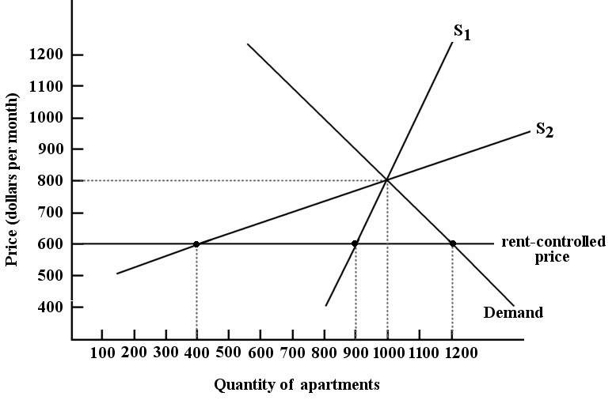

FIGURE 5-4

11) Refer to Figure 5-4. Suppose the government imposes a rent-controlled price of $600 per month on apartments in this city. In the short run we can expect the shortage of apartments to be ________ units.
A) 0
B) 200
C) 300
D) 800
E) 1000
Answer: C
Diff: 2
Topic: 5.2. rent controls
Skill: Applied
Learning Obj.: 5-3 Describe the relationship between economic surplus and the efficiency of a market.
User1: Graph
User2: Quantitative

12) Refer to Figure 5-4. Suppose the government imposes a rent-controlled price of $600 per month on apartments in this city. In the long run we can expect the shortage of apartments to be ________ units.
A) 0
B) 200
C) 300
D) 800
E) 1000
Answer: D
Diff: 2
Topic: 5.2. rent controls
Skill: Applied
Learning Obj.: 5-3 Describe the relationship between economic surplus and the efficiency of a market.
User1: Graph
User2: Quantitative
13) Refer to Figure 5-4. Suppose the government sets a rent ceiling at $900. In this situation, the rental price for an apartment is
A) $600.
B) $900.
C) any rent above $900.
D) the same as the free-market equilibrium rental price.
E) any rent below $600.
Answer: D
Diff: 2
Topic: 5.2. rent controls
Skill: Applied
Learning Obj.: 5-3 Describe the relationship between economic surplus and the efficiency of a market.
User1: Graph
User2: Quantitative

14) Refer to Figure 5-4. The difference between supply curve S1 and supply curve S2 in this market for apartments is that
A) S1 is not affected by a government controlled rental price.
B) S2 is not affected by a government controlled rental price.
C) S1 is more elastic than S2.
D) S1 is a short-run supply curve and S2 is a long-run supply curve.
E) S1 is a long-run supply curve and S2 is a short-run supply curve.
Answer: D
Diff: 2
Topic: 5.2. rent controls
Skill: Applied
Learning Obj.: 5-3 Describe the relationship between economic surplus and the efficiency of a market.
User1: Graph
User2: Quantitative

15) Refer to Figure 5-4. What is the significance of the difference in the slopes of the short-run supply curve (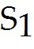) and the long-run supply curve (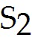) for apartments?
A) Over time, the supply of apartments shrinks in response to the controlled prices - the elasticity of supply decreases.
B) Over time, the demand for apartments shrinks in response to the controlled prices - the elasticity of supply increases.
C) Over time, the demand for apartments increases in response to the controlled prices - the elasticity of supply increases.
D) Over time, the supply of apartments increases in response to the controlled prices - the elasticity of demand increases.
E) Over time, the supply of apartments shrinks in response to the controlled prices - the elasticity of supply increases.
Answer: E
Diff: 2
Topic: 5.2. rent controls
Skill: Applied
User1: Graph
User2: Qualitative
16) The short-run supply for rental housing is quite ________ while the long-run supply for housing is quite ________.
A) elastic; inelastic
B) inelastic; elastic
C) flat; steep
D) inelastic; inelastic
E) elastic; elastic
Answer: B
Diff: 2
Topic: 5.2. rent controls
Skill: Recall
Learning Obj.: 5-3 Describe the relationship between economic surplus and the efficiency of a market.
User2: Qualitative

17) The long-run elasticity of supply of rental housing is greater than the short-run elasticity of supply because
A) changes in supply can occur very quickly, especially when rent controls are in place.
B) investment in new rental housing has such a short payback period.
C) changes in supply occur only after investment decisions are made regarding, for example, new construction or conversion of rental housing to other uses.
D) in the long run, landlords have no incentive to alter the supply of rental housing.
E) the demand for rental housing is changing continuously.
Answer: C
Diff: 2
Topic: 5.2. rent controls
Skill: Recall
Learning Obj.: 5-3 Describe the relationship between economic surplus and the efficiency of a market.
User2: Qualitative

5.3 An Introduction to Market Efficiency

1) Consider the demand curve for a product such as movie tickets, which shows how many tickets consumers wish to purchase at each possible price. Alternatively, we could view this demand curve in the following way:
A) for each quantity of movie tickets, the price on the demand curve shows the value that consumers place on that particular movie ticket.
B) for each quantity of movie tickets, the demand curve shows the economic surplus generated by the purchase of the tickets.
C) for each possible price, the demand curve shows the economic surplus generated by the purchase of the tickets.
D) for each quantity of movie tickets, the demand curve shows the extent of market inefficiency and deadweight loss.
E) for each quantity of movie tickets, the demand curve shows the additional cost to the producer of supplying that particular movie ticket.
Answer: A
Diff: 2
Topic: 5.3a. market efficiency and economic surplus
Skill: Applied
Learning Obj.: 5-4 Explain why government interventions that cause prices to deviate from their market‐clearing levels tend to be inefficient for society as a whole.
User2: Qualitative
2) Consider the supply curve for a product such as shipping crates, which shows how many crates producers want to sell at each possible price. Alternatively, we could view this supply curve in the following way:
A) for each quantity of shipping crates, the supply curve shows the economic surplus generated by the provision of that ticket.
B) for each possible price, the supply curve shows the economic surplus generated by the provision of those crates.
C) for each quantity of shipping crates, the supply curve shows the extent of market inefficiency and deadweight loss.
D) for each quantity of shipping crates, the supply curve shows the value that consumers place on that particular crate.
E) for each quantity of shipping crates, the price on the supply curve shows the additional cost to the producer of supplying that crate.
Answer: E
Diff: 2
Topic: 5.3a. market efficiency and economic surplus
Skill: Applied
Learning Obj.: 5-4 Explain why government interventions that cause prices to deviate from their market‐clearing levels tend to be inefficient for society as a whole.
User2: Qualitative

3) Suppose a downward-sloping demand curve intersects the horizontal axis at a point where quantity demanded equals 1250 units. What is the "value" that consumers place on the 1250th unit of this good?
A) a negative value
B) a positive value
C) $0
D) $1250
E) it depends on the position of the supply curve
Answer: C
Diff: 2
Topic: 5.3a. market efficiency and economic surplus
Skill: Applied
Learning Obj.: 5-4 Explain why government interventions that cause prices to deviate from their market‐clearing levels tend to be inefficient for society as a whole.
User2: Qualitative
4) Suppose a negatively sloped demand curve and a positively sloped supply curve intersect at a price and quantity combination of $100 and 600 units of the good. But suppose that producers actually produce and sell 610 units. What can we correctly say about market efficiency in this case?
A) The value placed on the final 10 units of the good by consumers exceeds the additional costs associated with their production — this market is not efficient.
B) The production and consumption of the additional 10 units of the good increases total economic surplus and increases market efficiency.
C) This market is efficient because economic surplus is maximized as production and consumption increase simultaneously.
D) This market is not efficient because quantity demanded for the good exceeds quantity supplied.
E) The value placed on the final 10 units of the good by consumers is less than the additional costs associated with their production — this market is not efficient.
Answer: E
Diff: 3
Topic: 5.3a. market efficiency and economic surplus
Skill: Applied
Learning Obj.: 5-4 Explain why government interventions that cause prices to deviate from their market‐clearing levels tend to be inefficient for society as a whole.
User2: Quantitative

5) When economists describe a market for a specific product as being economically "efficient," what do they mean?
A) Production techniques are such that resources are used in the most technologically efficient manner.
B) Consumption of the product is such that economic surplus is maximized.
C) Production of the product is such that economic surplus is maximized.
D) The quantity of the product produced and consumed is such that the economic surplus is maximized.
E) There are no price controls in place in that market.
Answer: D
Diff: 2
Topic: 5.3a. market efficiency and economic surplus
Skill: Recall
Learning Obj.: 5-4 Explain why government interventions that cause prices to deviate from their market‐clearing levels tend to be inefficient for society as a whole.
User2: Qualitative
6) Consider a competitive market for good X. A binding price floor and a binding price ceiling in this market would be similar to each other in that
A) each type of price control will lead to a reduction in deadweight loss and therefore an increase in efficiency in the market for good X.
B) the units of good X that will no longer be produced or consumed will not generate any economic surplus.
C) each type of price control results in a higher price paid by consumers, and therefore to a reduction in economic surplus.
D) each type of price control results in a lower price received by sellers, and therefore to a reduction in economic surplus.
E) additional units of good X will be produced and consumed, leading to an increase in economic surplus.
Answer: B
Diff: 2
Topic: 5.3a. market efficiency and economic surplus
Skill: Applied
Learning Obj.: 5-4 Explain why government interventions that cause prices to deviate from their market‐clearing levels tend to be inefficient for society as a whole.
User2: Qualitative

7) Each point on a demand curve shows the ________ price that consumers will pay to consume that quantity. The demand curve therefore shows the ________ to consumers from consuming the product.
A) maximum; cost
B) minimum; cost
C) maximum; value
D) minimum; value
E) equilibrium; equilibrium price
Answer: C
Diff: 2
Topic: 5.3a. market efficiency and economic surplus
Skill: Recall
Learning Obj.: 5-4 Explain why government interventions that cause prices to deviate from their market‐clearing levels tend to be inefficient for society as a whole.
User2: Qualitative

8) Each point on a supply curve shows the ________ acceptable price to firms for selling that unit; this price reflects ________ to firms from producing that unit.
A) minimum; the equilibrium price
B) maximum; the additional value
C) minimum; the additional value
D) maximum; the additional cost
E) minimum; the additional cost
Answer: E
Diff: 2
Topic: 5.3a. market efficiency and economic surplus
Skill: Recall
Learning Obj.: 5-4 Explain why government interventions that cause prices to deviate from their market‐clearing levels tend to be inefficient for society as a whole.
User2: Qualitative
9) Geoff is willing to pay $13 for a sixth entrance to a mountain bike park. The market price for entrance is $10.50. The bike park is willing to accept $8.75. The total economic surplus generated from Geoff's sixth trip to the bike park is
A) $1.75.
B) $2.50.
C) $13.00.
D) $10.50.
E) $4.25.
Answer: E
Diff: 2
Topic: 5.3b. price controls and market efficiency
Skill: Applied
Learning Obj.: 5-4 Explain why government interventions that cause prices to deviate from their market‐clearing levels tend to be inefficient for society as a whole.
User2: Quantitative

10) Consider a market that is in equilibrium with a market-clearing price. Economic surplus is shown by
A) the intersection of the supply and demand curves.
B) the area that is both below the demand curve and above the supply curve.
C) the area that is both above the demand curve and below the supply curve.
D) the area to the right of the market-clearing price and quantity.
E) the area below the supply curve up to the equilibrium quantity and below the demand curve beyond the equilibrium quantity.
Answer: B
Diff: 2
Topic: 5.3a. market efficiency and economic surplus
Skill: Recall
Learning Obj.: 5-4 Explain why government interventions that cause prices to deviate from their market‐clearing levels tend to be inefficient for society as a whole.
User2: Qualitative

11) If 10 000 snow tires are produced and purchased in the month of November, we can say that economic surplus is
A) the net value that society as a whole receives by producing and consuming those 10 000 snow tires.
B) the number of snow tires that are produced in excess of the equilibrium quantity.
C) the profit earned by the producers of those 10 000 snow tires.
D) the price at which the tires are sold multiplied by 10 000.
E) the net value to those consumers who purchased the 10 000 snow tires.
Answer: A
Diff: 3
Topic: 5.3a. market efficiency and economic surplus
Skill: Applied
Learning Obj.: 5-4 Explain why government interventions that cause prices to deviate from their market‐clearing levels tend to be inefficient for society as a whole.
User2: Qualitative
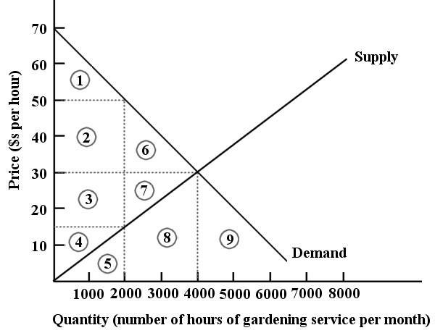

FIGURE 5-5

12) Refer to Figure 5-5. At the market-clearing price and quantity of $30 per hour and 4000 hours of gardening services purchased, the economic surplus is
A) the sum of the areas below the demand curve, but above the market-clearing price of $30 — i.e., areas 1, 2, 6.
B) the sum of the areas below the demand curve — i.e., areas 1, 2, 3, 4, 5, 6, 7, 8, 9.
C) the sum of the areas above the supply curve, but below the market-clearing price of $30 — i.e., areas 3, 4, 7.
D) the sum of the areas above the supply curve and below the demand curve — i.e., areas 1, 2, 3, 4, 6, 7.
E) the sum of the areas below the demand curve, up to 4000 hours — i.e., areas 1, 2, 3, 4, 5, 6, 7, 8.
Answer: D
Diff: 3
Topic: 5.3a. market efficiency and economic surplus
Skill: Applied
Learning Obj.: 5-4 Explain why government interventions that cause prices to deviate from their market‐clearing levels tend to be inefficient for society as a whole.
User1: Graph
User2: Qualitative
13) Refer to Figure 5-5. At the market-clearing price and quantity of $30 per hour and 4000 hours of gardening services, we can say that
A) economic surplus could be increased at a lower price because there would be more value to consumers.
B) economic surplus could be increased at a higher price because firms would generate more revenue.
C) economic surplus is maximized and the market is efficient.
D) the market is inefficient because there are some consumers who are not purchasing at this price.
E) the market is efficient because the government has imposed a market-clearing price and quantity.
Answer: C
Diff: 2
Topic: 5.3a. market efficiency and economic surplus
Skill: Applied
Learning Obj.: 5-4 Explain why government interventions that cause prices to deviate from their market‐clearing levels tend to be inefficient for society as a whole.
User1: Graph
User2: Qualitative

14) Refer to Figure 5-5. Suppose this market for gardening services is in a free-market equilibrium. If the government then imposes a price floor of $50 per hour for gardening services, the result would be
A) a loss of economic surplus of the areas 6 and 7.
B) a loss of economic surplus of the areas 2 and 6.
C) a loss of economic surplus of the area 1.
D) a loss of economic surplus of the areas 2, 3, 4, 6, and 7.
E) a loss of economic surplus of the areas 1, 2, 3, and 4.
Answer: A
Diff: 3
Topic: 5.3a. market efficiency and economic surplus
Skill: Applied
Learning Obj.: 5-4 Explain why government interventions that cause prices to deviate from their market‐clearing levels tend to be inefficient for society as a whole.
User1: Graph
User2: Qualitative
15) Refer to Figure 5-5. If production and consumption of gardening services were 5000 hours per month
A) the value placed by consumers on the last 1000 hours is less than the additional costs associated with their provision.
B) the provision of the last 1000 hours would decrease the amount of economic surplus in this market.
C) the resources going into the last 1000 hours of gardening service would be more highly valued elsewhere.
D) this market is not achieving efficiency.
E) all of the above.
Answer: E
Diff: 2
Topic: 5.3a. market efficiency and economic surplus
Skill: Applied
Learning Obj.: 5-4 Explain why government interventions that cause prices to deviate from their market‐clearing levels tend to be inefficient for society as a whole.
User1: Graph
User2: Qualitative

16) In general (and in the absence of market failures), economic surplus will be maximized and economic efficiency will be achieved
A) when the government is able to impose an equilibrium price.
B) when consumers and producers can agree on the most advantageous division of economic surplus.
C) when resources are allocated such that production of the good is maximized.
D) when the government successfully determines what is best for society as a whole.
E) in a competitive market where price is free to achieve its market-clearing equilibrium level.
Answer: E
Diff: 2
Topic: 5.3a. market efficiency and economic surplus
Skill: Applied
Learning Obj.: 5-4 Explain why government interventions that cause prices to deviate from their market‐clearing levels tend to be inefficient for society as a whole.
User2: Qualitative

17) Which of the following statements most accurately describes the concept of deadweight loss?
A) the loss of production that occurs when a binding price floor or ceiling is imposed
B) the loss of consumption that occurs when a binding price floor or ceiling is imposed
C) the overall loss of economic surplus that occurs when a market is inefficient
D) the total market value of the goods no longer produced when quantity exchanged is below the equilibrium quantity
E) the loss of economic surplus to consumers
Answer: C
Diff: 2
Topic: 5.3a. market efficiency and economic surplus
Skill: Recall
Learning Obj.: 5-4 Explain why government interventions that cause prices to deviate from their market‐clearing levels tend to be inefficient for society as a whole.
User2: Qualitative
18) One measure of the extent of market inefficiency is
A) how far market price deviates from equilibrium.
B) how far quantity exchanged deviates from equilibrium.
C) the size of the economic surplus.
D) the size of the deadweight loss.
E) the difference between total economic surplus and deadweight loss.
Answer: D
Diff: 2
Topic: 5.3a. market efficiency and economic surplus
Skill: Recall
Learning Obj.: 5-4 Explain why government interventions that cause prices to deviate from their market‐clearing levels tend to be inefficient for society as a whole.
User2: Qualitative

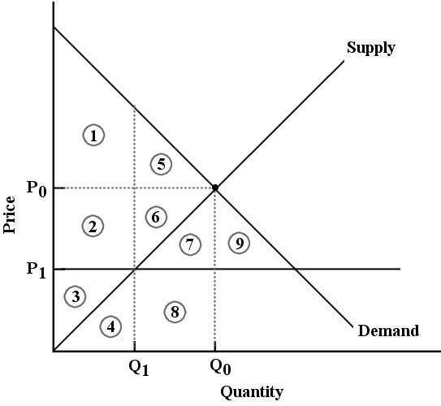
FIGURE 5-6

19) Refer to Figure 5-6. The market for good X is in equilibrium at P0 and Q0. Economic surplus is represented by
A) areas 1 and 5.
B) areas 2, 3, 4, 6, 7, 8.
C) areas 1, 2, 3, 5, 6.
D) areas 1, 2, 3, 4, 5, 6, 7, 8.
E) areas 2, 3, 4, 6, 7, 8, 9.
Answer: C
Diff: 2
Topic: 5.3b. price controls and market efficiency
Skill: Applied
Learning Obj.: 5-4 Explain why government interventions that cause prices to deviate from their market‐clearing levels tend to be inefficient for society as a whole.
User1: Graph
User2: Qualitative
20) Refer to Figure 5-6. The market for good X is in equilibrium at P0 and Q0. Now suppose the government imposes a ________ at P1. One result would be ________.
A) price ceiling; an increase in economic surplus represented by areas 5 and 6
B) price ceiling; a deadweight loss represented by areas 5, 6, 7 and 8
C) price floor; a deadweight loss represented by areas 5, 6, 7 and 8
D) price floor; a deadweight loss represented by areas 2, 6 and 7
E) price ceiling; a deadweight loss represented by areas 5 and 6
Answer: E
Diff: 2
Topic: 5.3b. price controls and market efficiency
Skill: Applied
Learning Obj.: 5-4 Explain why government interventions that cause prices to deviate from their market‐clearing levels tend to be inefficient for society as a whole.
User1: Graph
User2: Qualitative

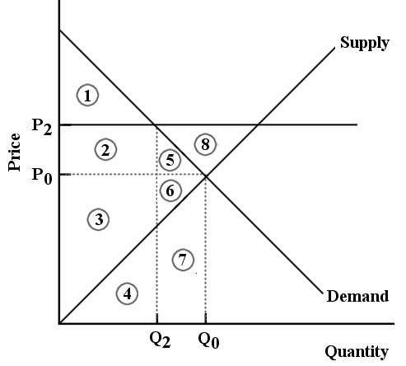

FIGURE 5-7

21) Refer to Figure 5-7. The market for good X is in equilibrium at P0 and Q0. Now suppose the government imposes a ________ at P2. One result would be ________.
A) price floor; an increase in economic surplus represented by area 1
B) price floor; a deadweight loss represented by areas 5 and 6
C) price ceiling; an increase in economic surplus represented by areas 2 and 5
D) price floor; a deadweight loss represented by area 8
E) price ceiling; a deadweight loss represented by areas 5 and 6
Answer: B
Diff: 2
Topic: 5.3b. price controls and market efficiency
Skill: Applied
Learning Obj.: 5-4 Explain why government interventions that cause prices to deviate from their market‐clearing levels tend to be inefficient for society as a whole.
User1: Graph
User2: Qualitative
22) In competitive markets, binding price floors and binding price ceilings lead to
A) a reduction in deadweight loss.
B) fairer prices for consumers and producers, and therefore are better for society as a whole.
C) an overall increase in economic surplus, and therefore to market efficiency.
D) a maximization of economic surplus.
E) an overall reduction in economic surplus, and therefore to market inefficiency.
Answer: E
Diff: 1
Topic: 5.3b. price controls and market efficiency
Skill: Recall
Learning Obj.: 5-4 Explain why government interventions that cause prices to deviate from their market‐clearing levels tend to be inefficient for society as a whole.
User2: Qualitative

23) Output quotas are commonly used in markets for
A) financial products.
B) exported goods.
C) imported goods.
D) agricultural products.
E) textiles.
Answer: D
Diff: 1
Topic: 5.3c. output quotas
Skill: Recall
Learning Obj.: 5-4 Explain why government interventions that cause prices to deviate from their market‐clearing levels tend to be inefficient for society as a whole.
User2: Qualitative

24) Consider the Canadian market for barley. Suppose a marketing board sets a production quota which is below the equilibrium quantity. The quota will cause the price of barley to ________ and the total revenue earned by Canadian barley farmers to ________.
A) rise; rise if demand is inelastic
B) rise; rise if demand is elastic
C) fall; fall if demand is inelastic
D) fall; fall if demand is elastic
E) remain unchanged; remain unchanged
Answer: A
Diff: 3
Topic: 5.3c. output quotas
Skill: Applied
Learning Obj.: 5-4 Explain why government interventions that cause prices to deviate from their market‐clearing levels tend to be inefficient for society as a whole.
User2: Qualitative
25) Consider Canada's east coast lobster fishery. Suppose the government sets a production quota which is below the equilibrium quantity. Relative to the free-market equilibrium, we can expect the result to be
A) an increase in price and a decrease in deadweight loss.
B) a decrease in price and a decrease in deadweight loss.
C) the free-market equilibrium price and quantity because the quota is not binding.
D) an increase in price and the introduction of a deadweight loss.
E) a decreased price.
Answer: D
Diff: 2
Topic: 5.3c. output quotas
Skill: Applied
Learning Obj.: 5-4 Explain why government interventions that cause prices to deviate from their market‐clearing levels tend to be inefficient for society as a whole.
User2: Qualitative

26) Suppose a binding output quota is imposed in a previously competitive market with free-market equilibrium price and quantity. The result is
A) higher price and higher quantity exchanged.
B) higher price and lower quantity exchanged.
C) lower price and lower quantity exchanged.
D) lower price and higher quantity exchanged.
E) no change in price or quantity exchanged.
Answer: B
Diff: 2
Topic: 5.3c. output quotas
Skill: Applied
Learning Obj.: 5-4 Explain why government interventions that cause prices to deviate from their market‐clearing levels tend to be inefficient for society as a whole.
User2: Qualitative

The diagram below shows the market for litres of milk.

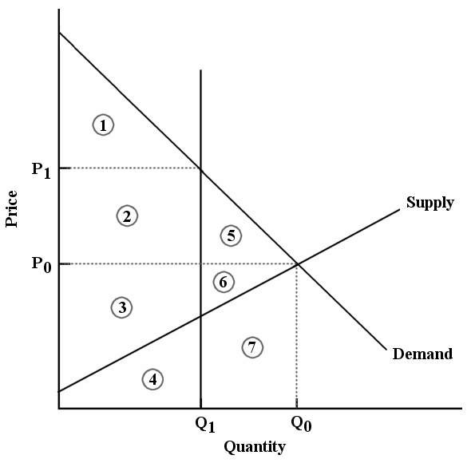

FIGURE 5-8

27) Refer to Figure 5-8. Suppose that a binding output quota is imposed on this market at quantity Q1. The loss in economic surplus due to the quota is equal to
A) areas 5 and 6.
B) areas 5, 6 and 7.
C) areas 2 and 5.
D) area 1.
E) areas 1, 2 and 3.
Answer: A
Diff: 2
Topic: 5.3c. output quotas
Skill: Applied
Learning Obj.: 5-4 Explain why government interventions that cause prices to deviate from their market‐clearing levels tend to be inefficient for society as a whole.
User1: Graph
User2: Qualitative

28) Refer to Figure 5-8. After the imposition of a milk quota at quantity Q1, economic surplus is represented by
A) areas 1, 2 and 5.
B) areas 3 and 4.
C) areas 1, 2 and 3.
D) areas 1, 2, 3, 4, 5, 6 and 7.
E) areas 2, 3, 5 and 6.
Answer: C
Diff: 2
Topic: 5.3c. output quotas
Skill: Applied
Learning Obj.: 5-4 Explain why government interventions that cause prices to deviate from their market‐clearing levels tend to be inefficient for society as a whole.
User1: Graph
User2: Qualitative

29) Refer to Figure 5-8. After the imposition of a milk quota at quantity 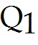, the deadweight loss in this market is represented by
A) area 1.
B) areas 1 and 4.
C) areas 1, 2, and 5.
D) areas 5 and 6.
E) areas 5, 6, and 7.
Answer: D
Diff: 2
Topic: 5.3c. output quotas
Skill: Applied
User1: Graph
User2: Quantitative
Consider the following demand and supply schedules for some agricultural commodity.

Price | Quantity Supplied | Quantity Demanded
$10 | 300 | 1100
$30 | 500 | 900
$50 | 700 | 700
$70 | 900 | 500
$90 | 1100 | 300
$110 | 1300 | 100

TABLE 5-2

30) Refer to Table 5-2. Total farmers' revenue under the free-market equilibrium is
A) $3000.
B) $15 000.
C) $35 000.
D) $63 000.
E) $75 000.
Answer: C
Diff: 2
Topic: 5.3c. output quotas
Skill: Applied
Learning Obj.: 5-4 Explain why government interventions that cause prices to deviate from their market‐clearing levels tend to be inefficient for society as a whole.
User1: Table
User2: Quantitative

31) Refer to Table 5-2. Consider the market-clearing equilibrium. If the government then imposes a production quota of 500 units, the price of this commodity will ________ relative to the free-market equilibrium price.
A) remain unchanged
B) rise by $20
C) fall by $20
D) rise by $40
E) fall by $40
Answer: B
Diff: 3
Topic: 5.3c. output quotas
Skill: Applied
Learning Obj.: 5-4 Explain why government interventions that cause prices to deviate from their market‐clearing levels tend to be inefficient for society as a whole.
User1: Table
User2: Quantitative
32) Refer to Table 5-2. Consider the market-clearing equilibrium. If the government then imposes a production quota of 500 units, the deadweight loss that is created is equal to
A) $1000.
B) $2000.
C) $3000.
D) $4000.
E) $5000.
Answer: D
Diff: 3
Topic: 5.3c. output quotas
Skill: Applied
Learning Obj.: 5-4 Explain why government interventions that cause prices to deviate from their market‐clearing levels tend to be inefficient for society as a whole.
User1: Table
User2: Quantitative

33) Refer to Table 5-2. Consider the market-clearing equilibrium. If the government then required that production increase to 900 units, the deadweight loss that is created is equal to
A) $1000.
B) $2000.
C) $3000.
D) $4000.
E) $5000.
Answer: D
Diff: 3
Topic: 5.3c. output quotas
Skill: Applied
Learning Obj.: 5-4 Explain why government interventions that cause prices to deviate from their market‐clearing levels tend to be inefficient for society as a whole.
User1: Table
User2: Quantitative

34) Refer to Table 5-2. Suppose we begin in a free-market equilibrium. If the government then imposes a production quota of 500 units, total farmers' income
A) increases by $800.
B) increases by $500.
C) remains unchanged.
D) decreases by $500.
E) decreases by $700.
Answer: C
Diff: 3
Topic: 5.3c. output quotas
Skill: Applied
Learning Obj.: 5-4 Explain why government interventions that cause prices to deviate from their market‐clearing levels tend to be inefficient for society as a whole.
User1: Table
User2: Quantitative
35) Consider the market for any agricultural commodity for which there exists a binding output quota and demand is inelastic. Any individual producer has a clear financial incentive to
A) produce a small amount beyond their individual quota amount.
B) leave the market.
C) give away their quota.
D) stop producing.
E) limit production of the commodity.
Answer: A
Diff: 3
Topic: 5.3c. output quotas
Skill: Applied
Learning Obj.: 5-4 Explain why government interventions that cause prices to deviate from their market‐clearing levels tend to be inefficient for society as a whole.
User2: Qualitative

36) Consider the market for any agricultural commodity for which there exists a binding output quota and demand is inelastic. One outcome of this situation is that
A) the price and quantity adjust back to the free-market equilibrium levels.
B) producers who were in this industry before the introduction of the quota are harmed.
C) producers leave this industry because total revenues fall as a result of the the quota.
D) it is difficult for new producers to enter this industry because the quotas are very expensive.
E) producers who enter this industry after the introduction of the quota benefit.
Answer: D
Diff: 3
Topic: 5.3c. output quotas
Skill: Applied
Learning Obj.: 5-4 Explain why government interventions that cause prices to deviate from their market‐clearing levels tend to be inefficient for society as a whole.
User2: Qualitative

37) In Canada we have government intervention in the dairy market in the form of quotas on milk production. What are two predicted economic effects of this policy?
A) a redistribution of income from consumers of dairy products to dairy farmers; and a reduction in the total amount of economic surplus in the dairy market
B) a redistribution of income from consumers of dairy products to dairy farmers; and a reduction in deadweight loss in the dairy market
C) a redistribution of income from dairy farmers to consumers of dairy products; a reduction in the total amount of economic surplus in the dairy market
D) a redistribution of income from dairy farmers to consumers of dairy products; and an increase in the total amount of economic surplus in the dairy market
E) an equitable distribution of income between dairy farmers and consumers of dairy products; and a reduction in the total amount of economic surplus in the dairy market
Answer: A
Diff: 2
Topic: 5.3c. output quotas
Skill: Applied
Learning Obj.: 5-4 Explain why government interventions that cause prices to deviate from their market‐clearing levels tend to be inefficient for society as a whole.
User2: Qualitative

